Lab: Unit Testing Arrays
Submit your solutions here: https://judge.softuni.org/Contests/4681/Unit-Testing-Arrays-Lab

Unit Test Array: Reverse Array
Look at the provided skeleton and examine the Reverse.cs class that you will test:
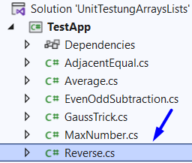
The method takes in an integer array, reverses it, and returns a string with the reversed numbers,
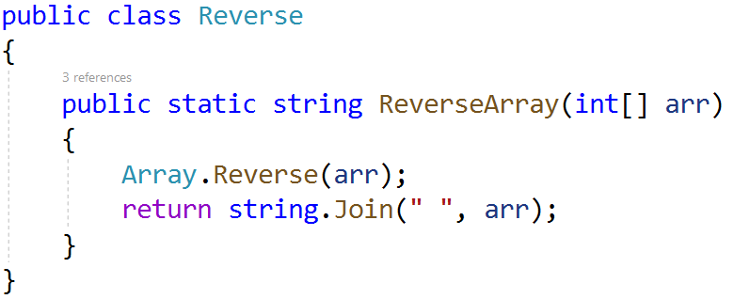
Then, look at the tests inside the ReverseTests.cs class:
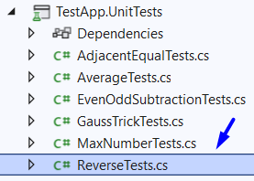
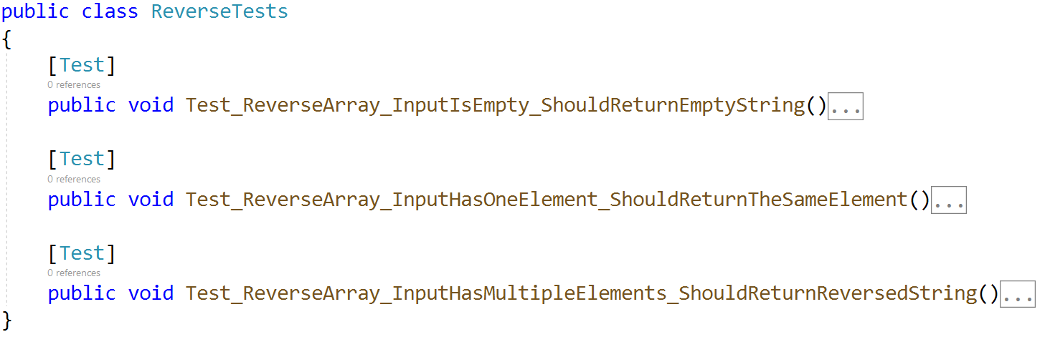
The first test is finished so you can have a reference, the second test is unfinished, your job is to finish writing it, and the final test is empty, and your task is to finish it. The tests should run when you're finished:
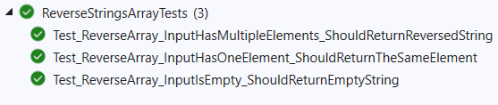

Unit Test Array: Even Odd Subtraction
Test a given method which takes in an array of integers and finds the difference between the sum of even numbers and the sum of odd numbers.
The method is found in the EvenOddSubtraction.cs file:
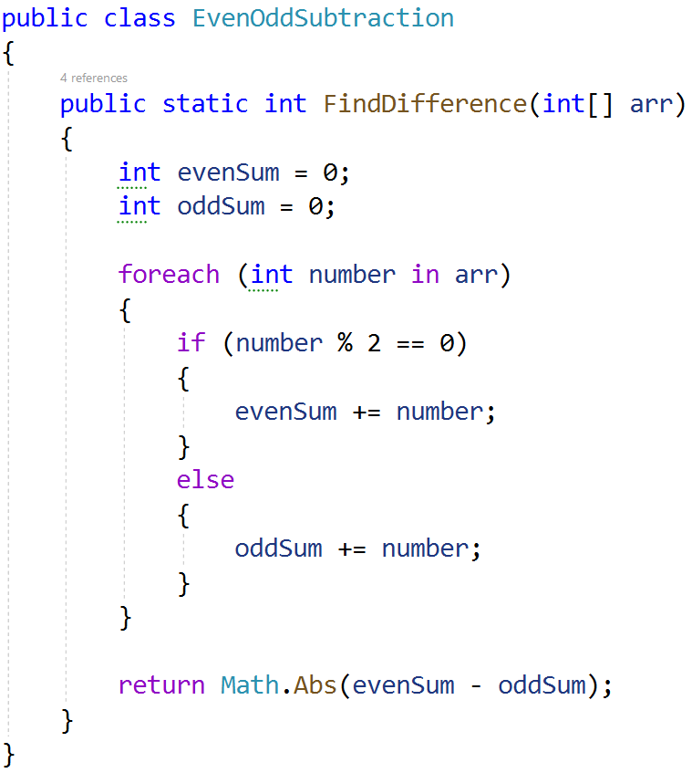
You are given again a test file EvenOddSubtractionTests.cs which contains 4 tests. One of them has been finished, one is finished partially, and two are empty for you to finish:
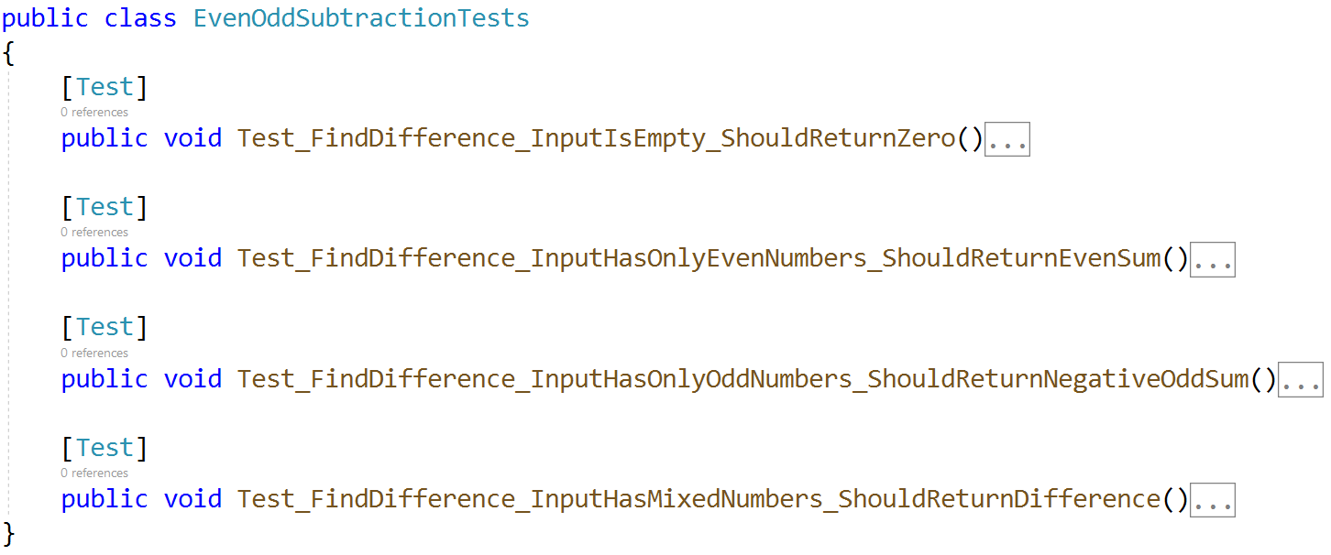
Finish the two tests and using the names of the other two finish writing the unit tests.
When you are ready make sure your tests run:
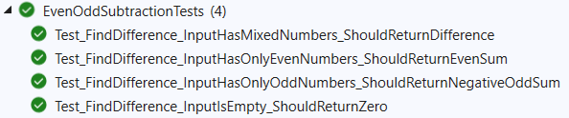

Unit Test Array: Average
For the final array problem, test a method which takes in an array of integers and finds the average of the sum of numbers.
The method is found in the Average.cs file:
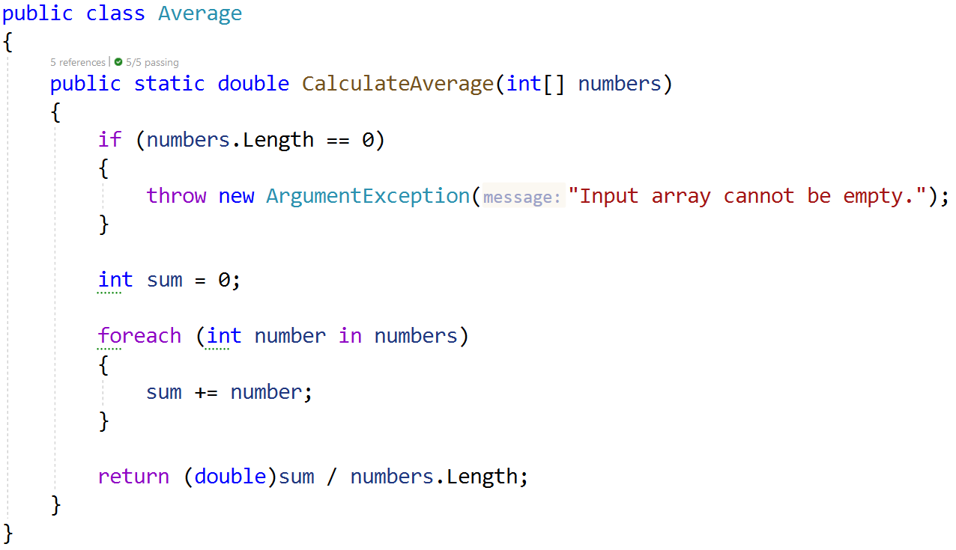
In the test file AverageTests.cs you have 4 tests. Once again, it's your task to finish the tests and run them: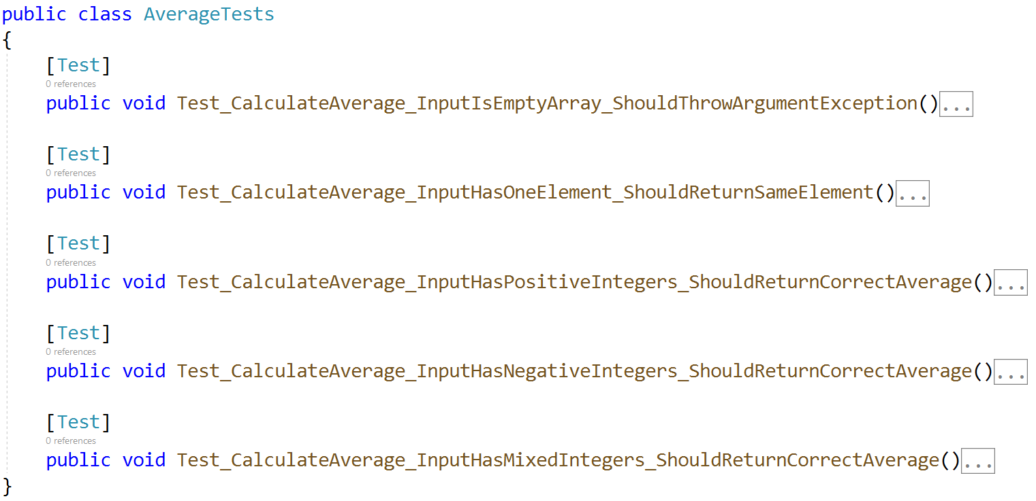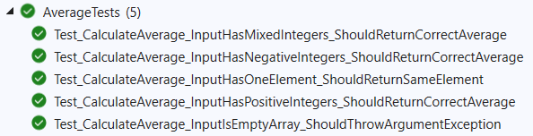

Unit Test Array: Even Length Words
Test a method which takes in an array of strings and returns a string with all even length words, separated by a single space.
The method is found in the EvenLengthWordsFilter.cs file:
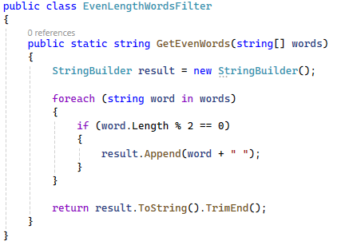
In the test file EvenLengthWordsFilterTests.cs, there are 5 test cases that need to be written:
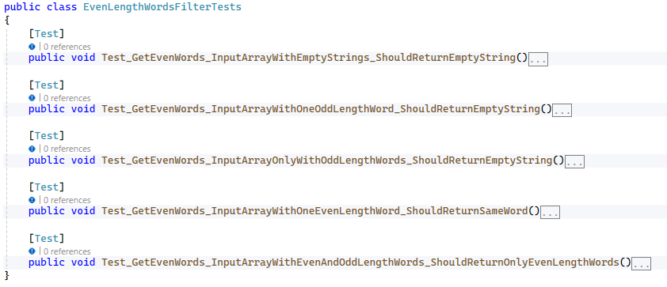
When you are ready make sure your tests run:
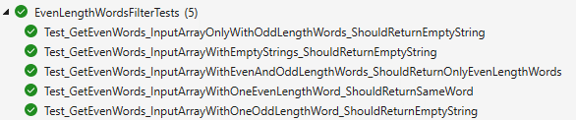

Unit Test Array: Prime Numbers
Test a given method which takes in an array of integers and returns an array of integers with all prime numbers.
The method is found in the PrimeNumberFinder.cs file:
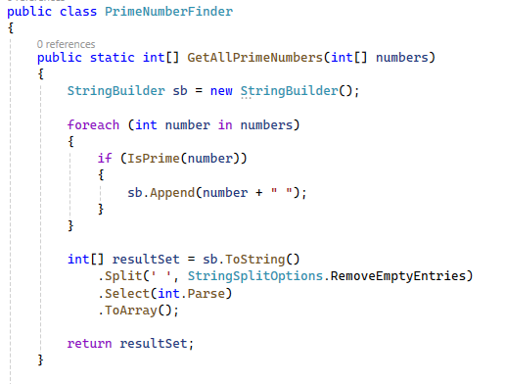
There is one helper method to find if the number is prime or not:
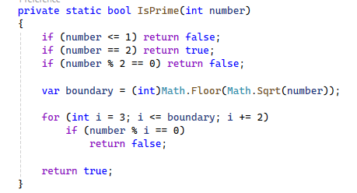
You are given a test file PrimeNumberFinderTests.cs containing 5 empty tests:
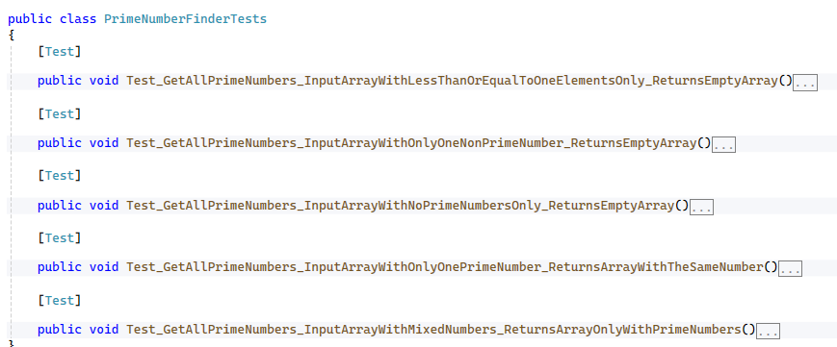
When you are ready make sure your tests run:
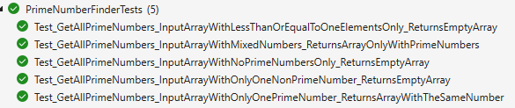

*Unit Test Array: Sorting
You are given two methods that sort an array in ascending order and return an array of double values.
The methods are found in the Sorting.cs file:
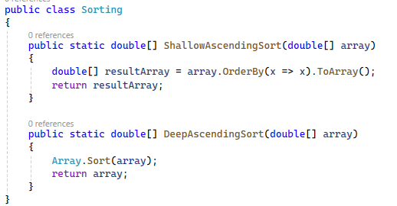
The ShallowAscendingSort method will sort the array and return a new one without changing the original array passed as a parameter.
The DeepAscendingSort method will change the original array and return it.
You are given a test file SortingTests.cs containing 4 empty tests:
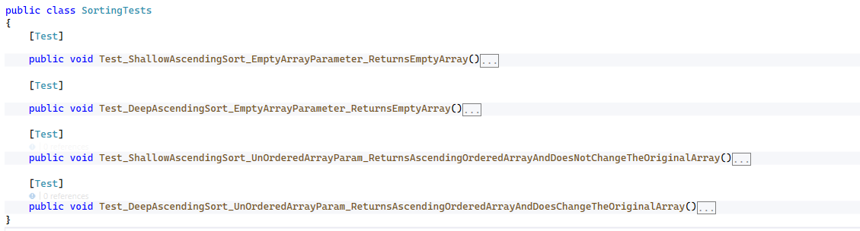
When you are ready make sure your tests run:
